Computer Networks

Lab Task #13

Saad Ahmad

20P-0051

Add 3x Laptops, 2x switch, 2x routers and 2x servers and connect them all.

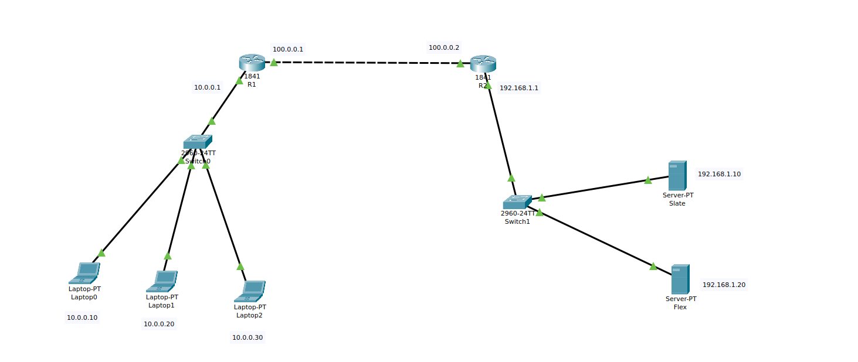

Now assign the IP addresses to the laptops, servers and routers:

**Laptop0:** 10.0.0.10

**Laptop1:** 10.0.0.20

**Laptop2:** 10.0.0.30

**Server1:** 192.168.1.10

**Server2:** 192.168.1.20

**F0/0 of R1:** 100.0.0.1

**F0/0 of R2:** 100.0.0.2

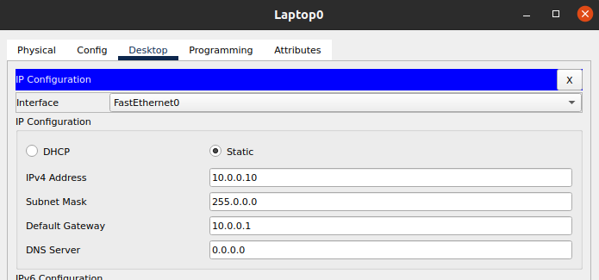

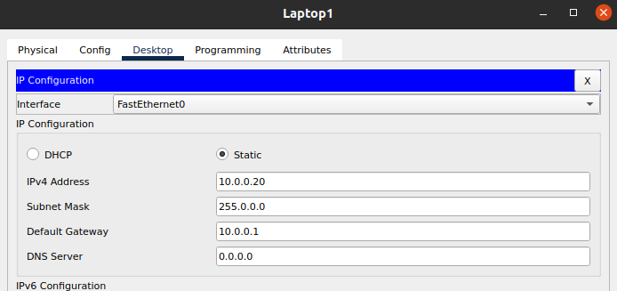

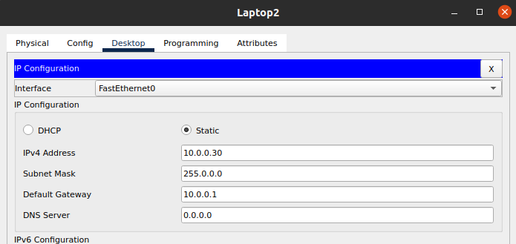

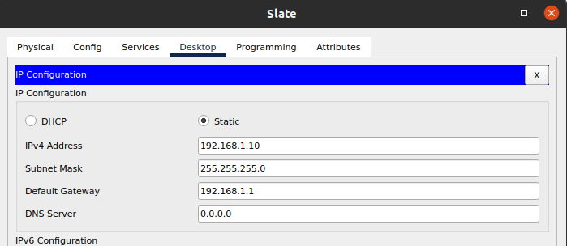

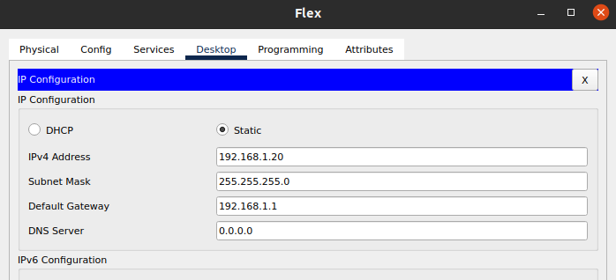

Configuring Router 1:

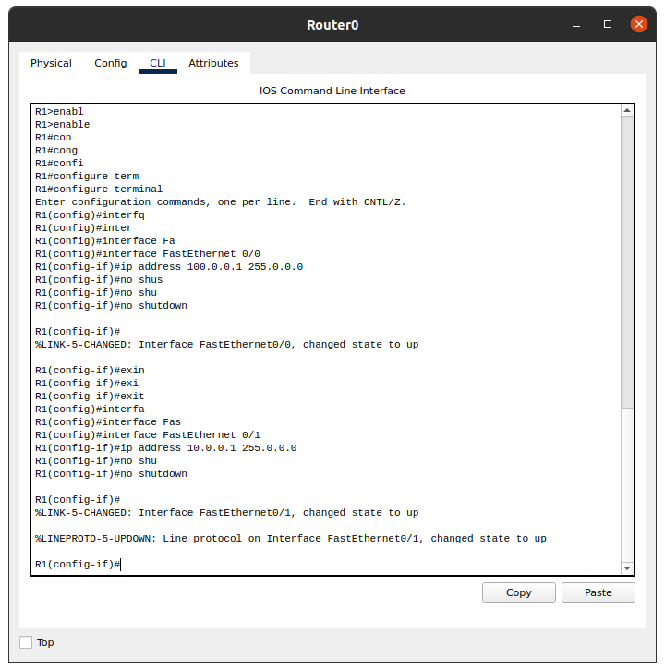

Configuring Router 2:

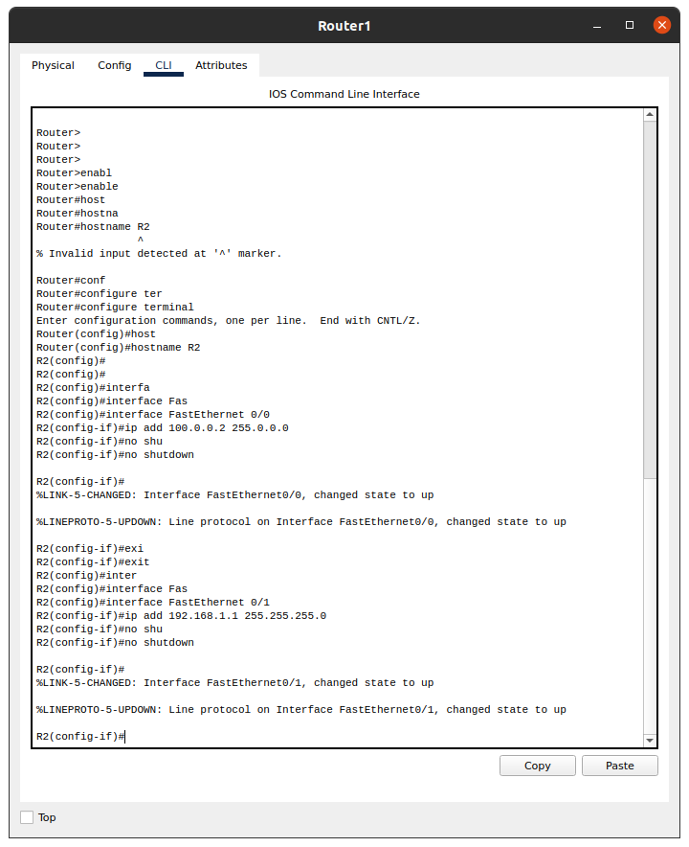

Configure Dynamic NAT on Router 1:

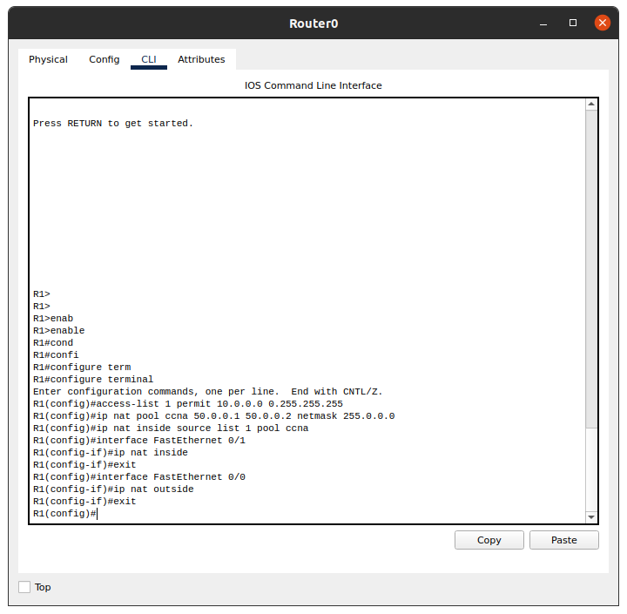

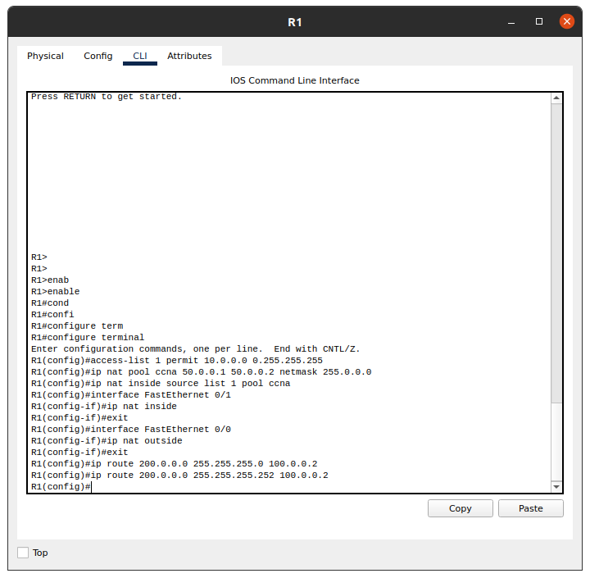

Configure Static NAT on Router 2:

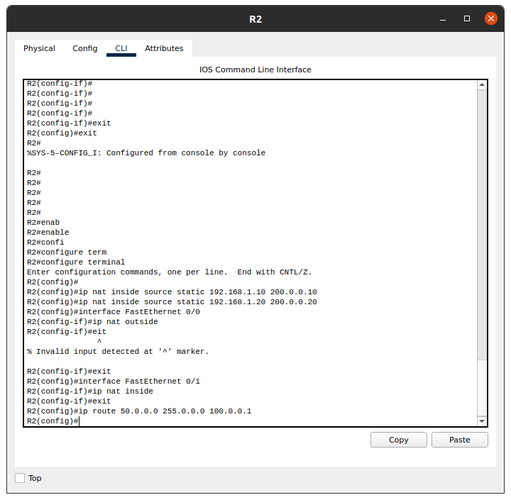

Checking the connection:

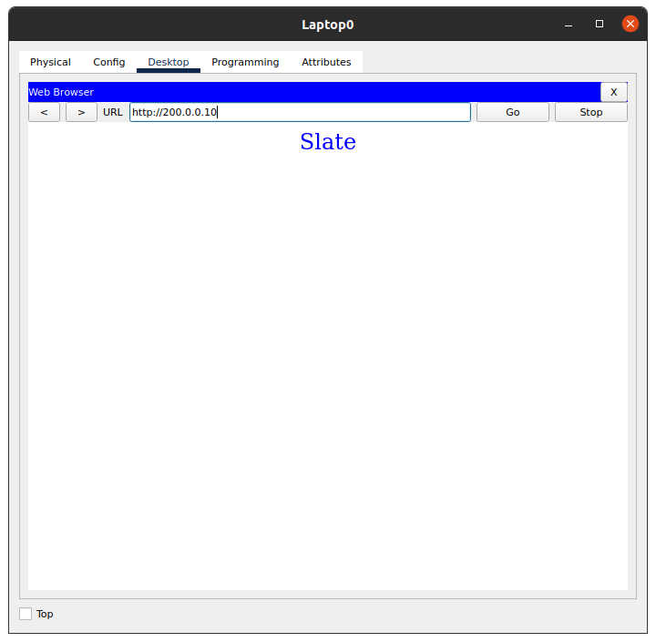

And

